

**PYTHON PROJECT**

**On**

**“Cab Booking System”**

***Submitted by:-***

|  |
| --- |
| **1.Raj Raushan, 11802089,B-46.** |
| **2.Divyanshu Tiwari,11802090,B-47.** |
| **3.Siddharth Sahoo, 11802128,B-48.** |

***Submitted To:-***

**Mr. Mir Mohammad Yousuf.**

**INTRODUCTION**

Our project entitled “ **Booking Cab System within LPU**” aims to book cabs at all the fare prices.

The aim of our project is to develop a system that is meant to partially computerize the work performed in the prepaid cab management like generating monthly daily bookings,records of routes available,fare charges for every route;store the record of the customer here in LPU. A cab conveys passengers between the locations of their choices. In LPU ,transport facility is quite helpful to the students and as well as to the faculties too via e-rickshaws within LPU campus. Our project will help all, to book cabs within the campus to reach their desired destination within less price and with an assurance to reach on time.

**REQUIREMENTS**

-**Hardware**

Processors: Intel® Core™ i5 processor, 2.2 Ghz, Intel UHD 620

Operating systems: Windows® 10.

-**Software**

IDLE software,xslx used.

**MODULAR REPRESENTATION**

1. Login Page

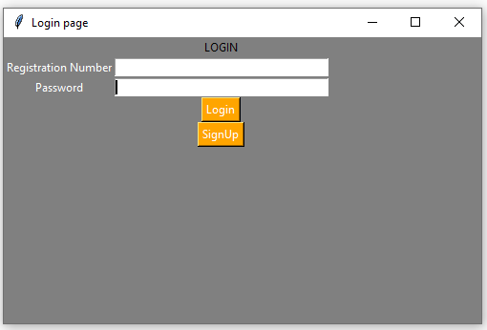

1. **Book a Ride**

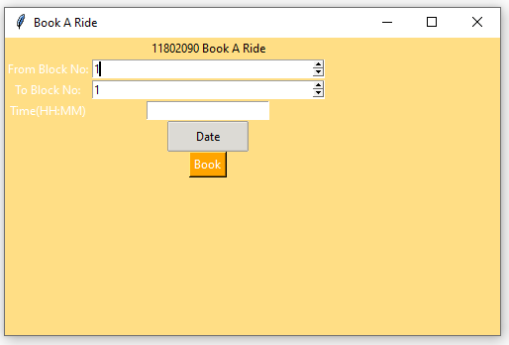

1. **Sign-Up**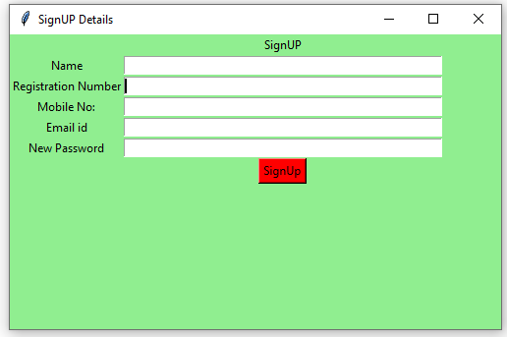

**CODE**

**#login page GUI**

from tkinter import *

import Signup

import Book

import openpyxl as xl

dic={}

gf=xl.load_workbook('DBMS/base2.xlsx')

sh=gf.active

for i in range(2,sh.max_row):

reg=sh.cell(i,2).value

passw=sh.cell(i,5).value

dic[reg]=passw

print(dic)

if __name__=="__main__":

def clear(): # clearing the content after storing

reg_no_field.delete(0, END)

password_field.delete(0, END)

reg_no_field.focus_set()

def valid():

try:

a=reg_no_field.get()

b=password_field.get()

if a not in dic.keys():

print("Username doesnt exist")

clear()

elif b!=dic[a]:

print("Incorrect paasword")

clear()

else:

Book.main(reg_no_field.get())

except ValueError:

print("Enter correct Values")

clear()

def focus1(event):

password_field.focus_set()

root = Tk()

root.configure(background='Grey')

root.title("Login page")

root.geometry("500x300")

**#Login label**

heading = Label(root, text="LOGIN", bg="Grey", fg="black")

heading.grid(row=0, column=1)

**#Name label**

reg_no = Label(root, text="Registration Number", bg="Grey", fg="White")

reg_no.grid(row=1, column=0)

**#password label**

password = Label(root, text="Password", bg="Grey", fg="White")

password.grid(row=2, column=0)

**#entry box**

reg_no_field = Entry(root)

password_field = Entry(root)

reg_no_field.bind("<Return>", focus1) reg_no_field.grid(row=1, column=1, ipadx="50")

password_field.grid(row=2, column=1, ipadx="50")

**#Login button**

Login = Button(root, text="Login", fg="white",bg="orange", command=valid) Login.grid(row=8, column=1)

**#Signup Button**

signup = Button(root, text="SignUp", fg="white", bg="orange", command=Signup.main2)

signup.grid(row=9, column=1)

**# start the GUI**

root.mainloop()

_____________________________________

from tkinter import *

**#Database part**

from openpyxl import *

fb=load_workbook('DBMS/base2.xlsx')

sheet=fb.active

def excel():

sheet.column_dimensions['A'].width = 20

sheet.column_dimensions['B'].width = 20

sheet.column_dimensions['C'].width = 20

sheet.column_dimensions['D'].width =20

sheet.column_dimensions['E'].width = 20

sheet.cell(row=1, column=1).value =

"Name"

sheet.cell(row=1, column=2).value = "Registration Number"

sheet.cell(row=1, column=3).value = "Mobile Number"

sheet.cell(row=1, column=4).value = "Email-Id"

sheet.cell(row=1, column=5).value = "Password"

**#database part end**

**#main function for signup form**

def main2():

def focus1(event):

Reg_field.focus_set()

def focus2(event):

Mob_field.focus_set()

def focus3(event):

email_id_field.focus_set()

def focus4(event):

passwor_field.focus_set() def clear():**# clearing the content after storing**

name_field.delete(0, END)

Reg_field.delete(0, END)

Mob_field.delete(0, END)

email_id_field.delete(0, END)

passwor_field.delete(0, END)

def insert(): #updating the data base

if (name_field.get() == "" and Reg_field.get() == "" and Mob_field.get() == "" and email_id_field.get() == "" and passwor_field==""):

print("empty input")

else:

cr = sheet.max_row

sheet.cell(row=cr + 1, column=1).value = name_field.get()

sheet.cell(row=cr + 1, column=2).value = Reg_field.get()

sheet.cell(row=cr + 1, column=3).value = Mob_field.get()

sheet.cell(row=cr + 1, column=4).value = email_id_field.get()

sheet.cell(row=cr + 1, column=5).value = passwor_field.get()

fb.save('DBMS/base2.xlsx')

name_field.focus_set()

clear()

**# create a GUI window**

root = Tk()

root.configure(background='light green')

root.title("SignUP Details")

root.geometry("500x300")

**#Label**

heading = Label(root, text="SignUP", bg="light green")

name = Label(root, text="Name", bg="light green")

Reg_no = Label(root, text="Registration Number", bg="light green")

Mob_no = Label(root, text="Mobile No:", bg="light green")

email_id = Label(root, text="Email id", bg="light green")

passwor=Label(root, text="New Password", bg="light green")

**#grids for Label**

heading.grid(row=0, column=1)

name.grid(row=1, column=0)

Reg_no.grid(row=2, column=0)

Mob_no.grid(row=3, column=0)

email_id.grid(row=4, column=0)

passwor.grid(row=5,column=0)

**#Entry**

name_field = Entry(root)

Reg_field = Entry(root)

Mob_field = Entry(root)

email_id_field = Entry(root)

passwor_field=Entry(root)

**#bind**

name_field.bind("<Return>", focus1)

Reg_field.bind("<Return>", focus2)

Mob_field.bind("<Return>", focus3)

email_id_field.bind("<Return>", focus4)

**#grids for Entry**

name_field.grid(row=1, column=1, ipadx="100")

Reg_field.grid(row=2, column=1, ipadx="100")

Mob_field.grid(row=3, column=1, ipadx="100")

email_id_field.grid(row=4, column=1, ipadx="100")

passwor_field.grid(row=5,column=1,ipadx="100")

excel()

submit = Button(root, text="SignUp", fg="Black", bg="Red", command=insert)

submit.grid(row=8, column=1)

root.mainloop()

_____________________________________

import tkinter as tk

from tkinter import ttk

from tkcalendar import Calendar, DateEntry

**#Database part**

from openpyxl import *

sb=load_workbook('Database1.xlsx')

sheet=sb.active

**#database part end**

fu2=""

def main(R):

d=R+" Book A Ride"

def store():

if (t.get()==""):

print("empty Time")

else:

cr = sheet.max_row

sheet.cell(row=cr + 1, column=1).value = w.get()

sheet.cell(row=cr + 1, column=2).value = y.get()

sheet.cell(row=cr + 1, column=3).value = R

sheet.cell(row=cr + 1, column=4).value = fu2

sheet.cell(row=cr + 1, column=5).value = t.get()

sb.save('Database1.xlsx')

main = tk.Tk()

ourMessage ='Your ride will arrive in a minute'

messageVar = tk.Message(main, text = ourMessage)

messageVar.pack( )

main.mainloop( )

def fu():

global fu2

fu2=cal.selection_get()

top = tk.Toplevel(root)

cal = Calendar(top,

font="Arial 14", selectmode='day',

cursor="hand1", year=2019, month=11, day=5)

cal.pack(fill="both", expand=True)

ttk.Button(top, text="ok", command=fu).pack()

root =tk.Tk()

s = ttk.Style(root)

s.theme_use('clam')

root.configure(background='#ffde85')

root.title("Book A Ride")

root.geometry("500x300")

**#Login label**

heading = tk.Label(root, text=d, bg="#ffde85", fg="black")

heading.grid(row=0, column=1)

**#Name label**

From = tk.Label(root, text="From Block No:", bg="#ffde85", fg="White")

From.grid(row=1, column=0)

**#password label**

To = tk.Label(root, text="To Block No:", bg="#ffde85", fg="White")

To.grid(row=2, column=0)

Time = tk.Label(root, text="Time(HH:MM)", bg="#ffde85", fg="White").grid(row=3,column=0)

w=tk.Spinbox(root, from_ = 1, to = 58)

y=tk.Spinbox(root, from_ = 1, to = 58)

t=tk.Entry(root)

t.grid(row=3, column=1)

w.grid(row=1, column=1, ipadx="50")

y.grid(row=2, column=1, ipadx="50")

# tim=TimeEntry(top, width=12, background='darkblue',

#5 foreground='white', borderwidth=2)

ttk.Button(root, text='Date', command=example1).grid(row=4,column=1)

**#Login button**

Book = tk.Button(root, text="Book", fg="white", bg="orange", command=store)

Book.grid(row=5, column=1)

root.mainloop()

**FLOW CHART**

CAB Management System

Book a Ride

Sign Up

LOGIN